Grain Size Automatic Determination for 7050 Al Alloy Based on a Fuzzy Logic Method

Zhang Lixin1,2, Xu Zhengguang1, Wei Shuailing1,3, Ren Xuechong 2, Wang Meiling2

1 School of Automation and Electrical Engineering, University of Science & Technology Beijing, Beijing 100083, China; 2 National Center of Materials Service Safety, University of Science & Technology Beijing, Beijing 100083, China;  3 Information Dept，Handan Central Hospital，Handan 056001, China

**Abstract:** Grain size is one of the crucial parameters in the microstructure analysis of high strength aluminum alloy. This information is commonly derived based on manual processes. However, these manual processes may take long time and error are prone to occur. Nowadays，the rapid development of the digital image processing and the pattern recognition technologies provides a new methodology for the quantitative metallographic analysis. Artificial intelligence utilized in realizing automatic metallographic analysis can overcome the drawbacks of the manual processes. In the present paper we presented a new method of digital image processing for determining the grain sizes of the metallographic images. To derive the grain sizes of the digital metallographic images, the digital image processing was applied to extract grain boundary by proposing a new edge detection algorithm based on fuzzy logic. Extensive metallographic images with different qualities were tested to validate this method. Practical application cases were presented here. The grain size was calculated in accordance with American Society for Testing Material (ASTM) standards.

**Key words:** microstructure analysis; grain size; fuzzy logic; edge detection; aluminum alloy

Grain size determination plays an important role in the metallic material research, and it can get the information related to the materials’ properties, such as yield strength, tensile strength and elongation, which have significant influences on properties of materials [1]. Traditional methods of the grain size determination are fundamentally dependent on the manual processes leading to time-consuming and error are prone to occur. With the development of the computing and image processing technologies, the digital image processing and pattern recognition techniques have recently become primary tools for the automatically quantitative metallographic analysis and the grain size determination[2-5]. Commercial metallographic analyzers are usually equipped with the specialized image processing appliances, such as the Image-Pro Plus (IPP), Image Tool and Image J, and are widely used in the metallographic microstructure analysis. Although these appliances reduce manual workloads and improve the efficiency of analysis to some extent, the instructions of the appliances are still complex, e.g., many parameters have to be manually set up and operating steps require user’s intervention. Additionally, the appliances have many specific requirements for the complicated preparation of the metallographic images of the specimens. It is difficult to identify grain boundaries in the images with low contrast and bad defined boundaries.

Many new image processing algorithms have been introduced and achieved great improvements in grain size determination[6], but there are still some shortcomings which need to be resolved. Because the characteristics of different alloy’s metallographic images differ from each other, the commonest problem is that the universality of existing methods is very low. Jiang et al. used the multi-scale geodesic dilation algorithm to restore and reconstruct the grain boundaries based on the improved definition of dilation [7]. Deng et al. proposed a new algorithm based on the Canny algorithm and a gray scale contour line to get enclosing edge of metallographic structure [8]. The automation level of these methods is still considered low. Some procedures still need to be performed manually. C. Park and Yu Ding et al. used a convexity analysis to split composite boundaries into individual components and recover the missing components of the boundary using FPCA (functional principal component analysis)-based missing value estimation [9]. The involved algorithms in above works are still time-consuming. Dengiz et al. used the neural network and the fuzzy logic algorithms to detect the grain boundary of steel alloys[10]. Łukasz Rauch et al. has used the Feed-Back Pulse Coupled Neural Network optimized by the bio-inspired optimization algorithms to segment the material microstructure images [11]. Although they can accurately extract and position the edge, the obtained boundaries are not continuous and smooth.

In the present work, based on some metallographic images of a 7050 aluminum alloy, one of the high-strength aluminum alloys, as the research object, a methodology focused on automatic grain size determination was introduced. High-strength aluminum alloy is the key material of the high-speed rail, which attracts much attentions of researchers. According to the features of the metallographic images and the requirements of grain boundary extraction, we proposed a new edge detection method based on fuzzy logic. After pre-processed, the grain boundaries were extracted. Combined with the mathematical morphology method and other post-processing, the reconstruction of the discontinuous grain boundaries was investigated on the reliability of automatic extraction of the grain boundary.

**1 Experiment**

Metallographic specimen preparation process mainly consists of four stages: sampling, grinding, polishing and etching with a suitable etchant to reveal the microstructure. In the first stage, the 7050 aluminum alloy metallographic specimen was taken from the die forging axle box of a high speed train. Grinding and polishing were used to ensure the surface uniformity of the specimen. We used sand paper to grind the surface and a polishing machine to polish the specimen. The specimen had to be etched to view the microstructure. NaOH solution with a concentration of 5% is the common etchant for aluminum alloy. After the aluminum alloy was etched for 1~2 min and cleaned by the dilute nitric acid and alcohol, the grain boundary could be visually examined. At the end, the metallographic images could be acquired under a metallographic microscope.

The image processing, reconstruction, visualization and automatic grain size determination were performed on a computer with a 2 GHz Intel Core 2 dual-core processor, 2 GB of RAM and NVidia GT240 discrete graphics cards. All the procedures and algorithms were realized by VC programming (Visual Studio 2010, Microsoft). The image processing was also carried out by Image-Pro Plus 6.0 (Media Cybernetics Inc.) for the comparison of the proposed method.

**2 Results and Discussion**

After the digital images have been captured, they must be processed to meet the requirements of automatic determination of the grain size. However, there exist too many factors influencing the quality of the images, such as illumination conditions and surface irregularities. Fig.1a shows an original aluminum alloy metallographic image. Fig.1b corresponds to part of the square in Fig.1a. The figure indicates that the metallographic image have low contrast, severe noise, and bad defined boundaries. Traditional image processing methods, for instance, the global threshold method (two-peak method, iterative method and Otsu method) and the differential edge detection operators (Sobel, Prewitt, Laplacian of Gaussian and Canny), cannot obtain ideal results. Fig.1c displays the threshold result of the Fig.1b obtained through Otsu method and indicates that the method is not capable of separating grain boundaries and background.

In order for yielding desirable results, other efficient image processing techniques must be introduced. The proposed algorithm developed is based on the fuzzy logic. After the digital images’ noises are eliminated from the pre-processing stage, a fuzzy model based on the fuzzy logic is constructed to calculate the membership of a pixel to edge point, and produces a reconstructed image. Then the image is decon- structed by the decision function. Finally, the morphology and other methods are invoked in the further processing. The described process flow is summarized in the Fig.2.

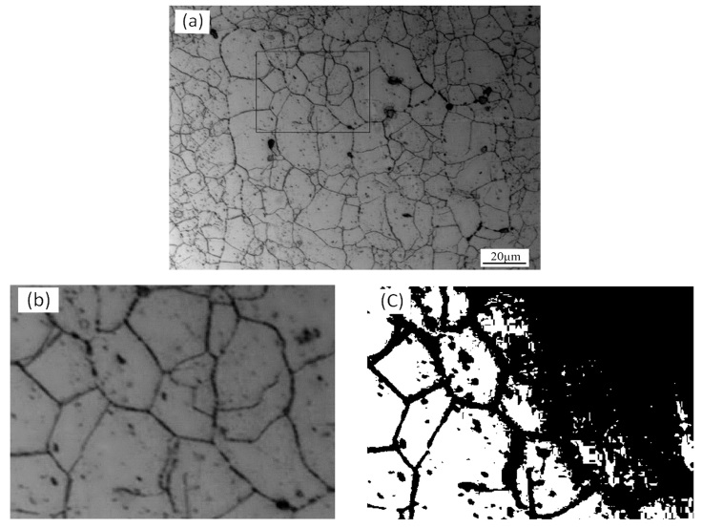

a

b

c



20 μm

5 μm

5 μm

Fig.1 Metallographic images of 7050 Al alloy: (a) original image, (b) zoom view of block in Fig.1a, and (c) segmented by Otsu method

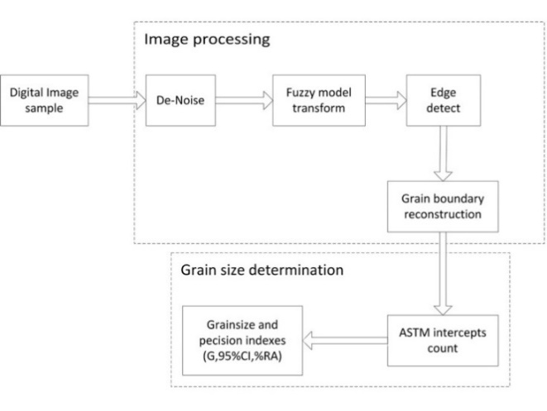

Digital image

sample

De-noise

Fuzzy model

transform

Edge

detect

Grain boundary

reconstruction

ASTM intercepts

count

Grain size and

precision indexes

(G, 95%CI, %RA)

Grain size determination

Image processing

Fig.2 Method flow diagram

**2.1 Pre-processing**

The digital images often contain noises due to defects in the process of preparing the metallographic specimen. Additional pre-processes should be done to eliminate the noises. The [Median](app:ds:median) [filter](app:ds:filter) and the [Gaussian](app:ds:Gaussian) [filter](app:ds:filter) are most widely used to eliminate the noises. The Median filter is a nonlinear filter, which can preserve edge information by removing the pepper-salt noise; whereas, the [Gaussian](app:ds:Gaussian) [filter](app:ds:filter) is a smooth linear filter, which can eliminate the Gaussian noise effectively. The specific processing methods should be chosen to eliminate the noises based on requirements.

**2.2 Extracting grain boundary by fuzzy logic**

2.2.1 Fuzzy logic edge detect algorithm

As shown in the Fig.3a, the grain boundary is a roof edge. The edge pixel point P is significantly different from the adjacent non-edge pixels. The edge pixels are relatively faint. The gray value of the edge pixel P is usually less than the non-edge pixels. In a certain area range, the number of pixels belonging to the edge is usually less than the number of non-edge pixels. Based on such properties of the metallographic images, an edge detection algorithm based on the fuzzy logic has been proposed to detect the grain boundary. The fuzzy model is utilized to compare the pixels’ properties to determine whether the pixels are on the edge. The decision whether the pixel is on the edge or not is made by evaluating pixel’s and its neighborhood’s properties by the fuzzy model[12,13].

First, we select a pixel *p*(*x*, *y*) from the digital image as a central point. In the vicinity of this pixel, a window *W*(*x*, *y*) size of *n* is selected as follow:



Based on the analysis of the correlation between pixels within *W*(*x*, *y*), a fuzzy membership model *μ*(*p*) has been proposed, which measures the membership degree. The *μ*(*p*) is defined as follow:



 $μ\left(p\right)=\frac{1}{e^{[p(x,y)-a(x,y)]}+1}$ (1)

where, *p*(*x*, *y*) is the gray value of the center pixel in the *W*(*x*, *y*). *μ*(*p*) is a scalar value within [0, 1] and the *a*(*x*, *y*) is the average value of all pixels. *a*(*x*, *y*) is given by the following equation:

 $a(x,y)=\frac{\sum_{k=(x-((n-1)/2))}^{(x+((n-1)/2))}{(\sum_{l=\left(y-\left(\frac{n-1}{2}\right)\right)}^{\left(y+\left(\frac{n-1}{2}\right)\right)}{p\left(k,l\right)})}}{n^{2}}$ (2)

The pixels’ membership degree to the grain boundary is obtained by traversing the image pixel utilizing the new model. The higher value of the pixel’s membership degree indicates higher probability that the pixel belongs to the grain boundary. We can reconstruct the image through multiplying *μ*(*p*) by 255. Fig.3b displays the reconstructed image (*n*=35). The edge information of the grain boundary is enhanced significantly compared with the traditional methods. We also learn that a pixel’s membership is smaller when the background pixel is closer to the edge pixels. We could conclude that the fuzzy model used to reconstruct an image can eliminate most noises near the edge and enhance the edge information.

The very important process is to select a decision function which is established based on the idea of Otsu method. The decision function is defined as following:

 $p_{t}\left(x,y\right)=\left\{\begin{aligned}0 μ≥t \\ \\ \\ 255 μ<t \end{aligned}\right.$ (3)

where, *pt*(*x*, *y*) is the gray value of a pixel upon which the decision function is chosen. The *pt*(*x*, *y*) = 0 means that the pixel is either an edge point, or is in the background. *t* is the threshold value and calculated using the Otsu method. Fig.4 displays the edge detection results based on the fuzzy logic algorithm with different *n*. The figure tells us that the fuzzy model is very sensitive to the noise, although the grain boundary information can be well extracted through the fuzzy logic algorithm. The pre-processes cannot completely eliminate the noises. When the single-scale fuzzy model is used to detect the grain boundary, the noise may be detected and amplified.

2.2.2 Algorithm improvement

From the original image demonstrated in Fig.3a, the distribution of the edge information is usually fixed, whereas the noises are random. When the size of the fuzzy model changes, the noises in the segmented images also change but the edge information is relatively fixed. Therefore, a multi-scale fuzzy model is proposed as following:

 (4)

where, two windows, *W*(*x*, *y*) and *W*′(*x*, *y*,) with different sizes (*n*≠*n*′) are used. The *a*(*x*, *y*) and the *a*′(*x*, *y*) are the average values of the two windows. The formula requires a smaller

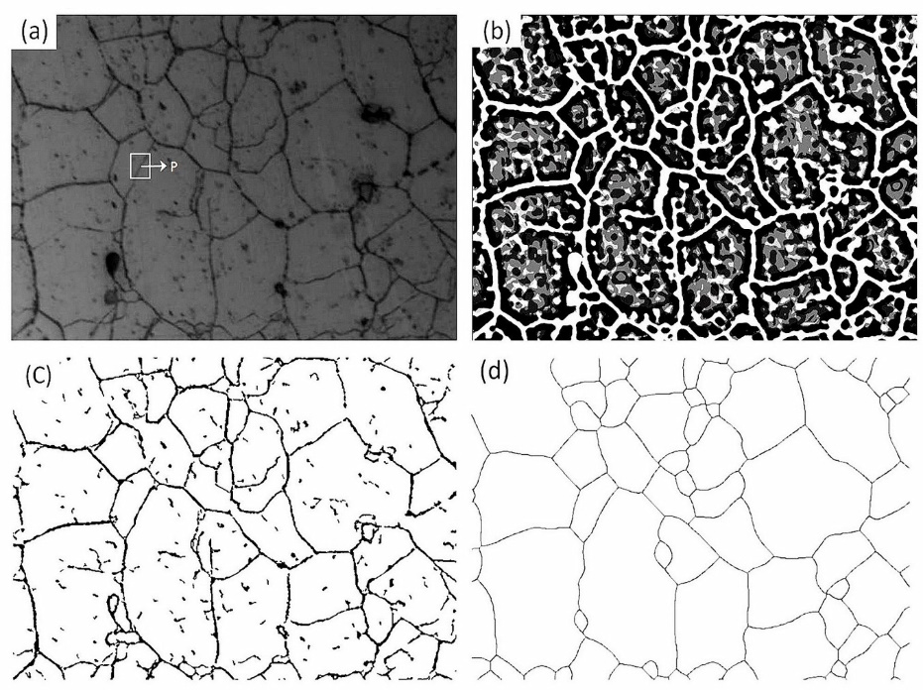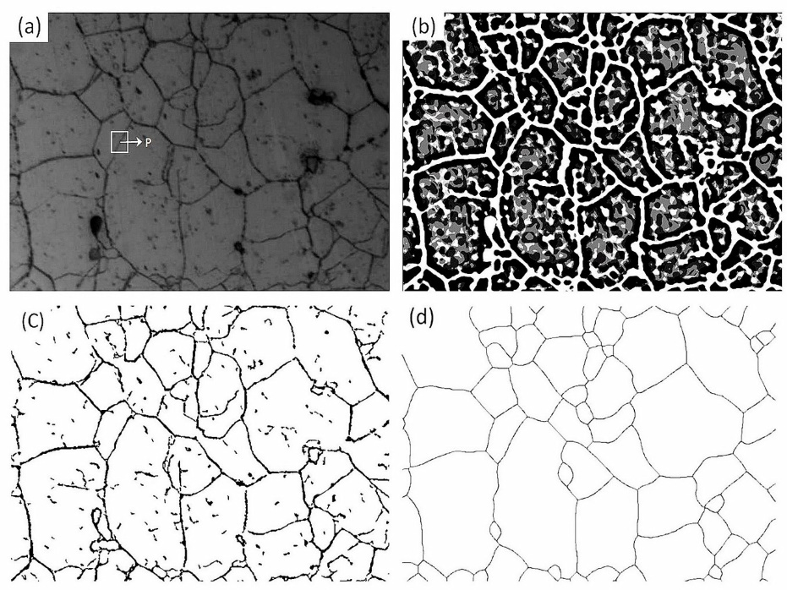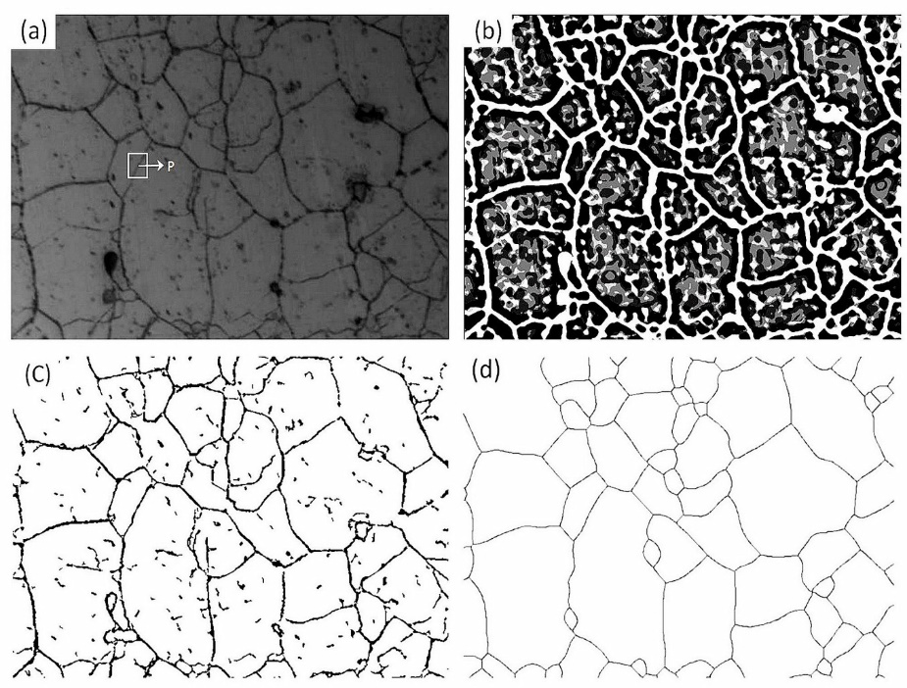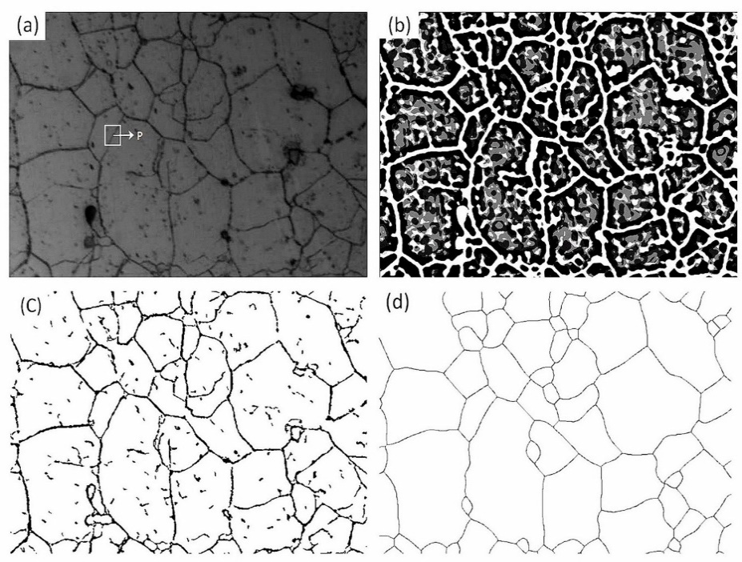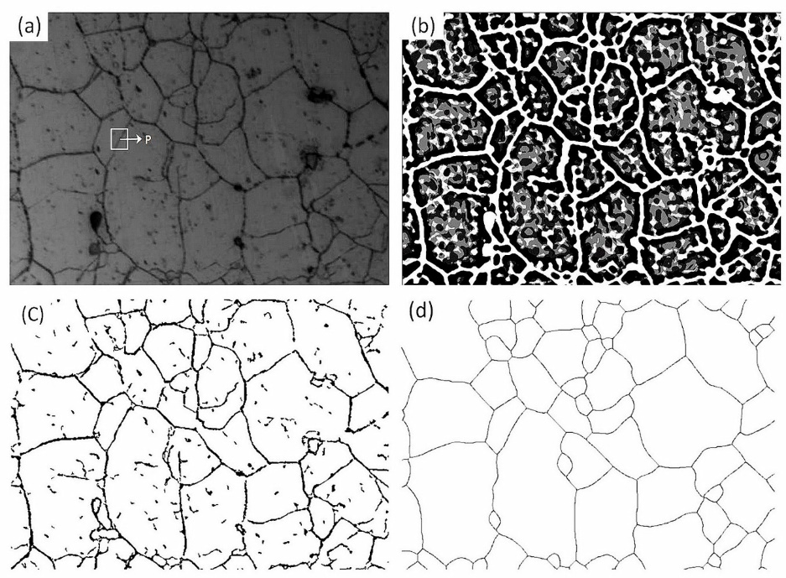

a

b

c

d

10 μm

Fig.3 Procedure of grain boundary extraction: (a) edge pixel P, (b) reconstructed image by the fuzzy model, (c) edge-detected image,

and (d) enclosed grain boundary image

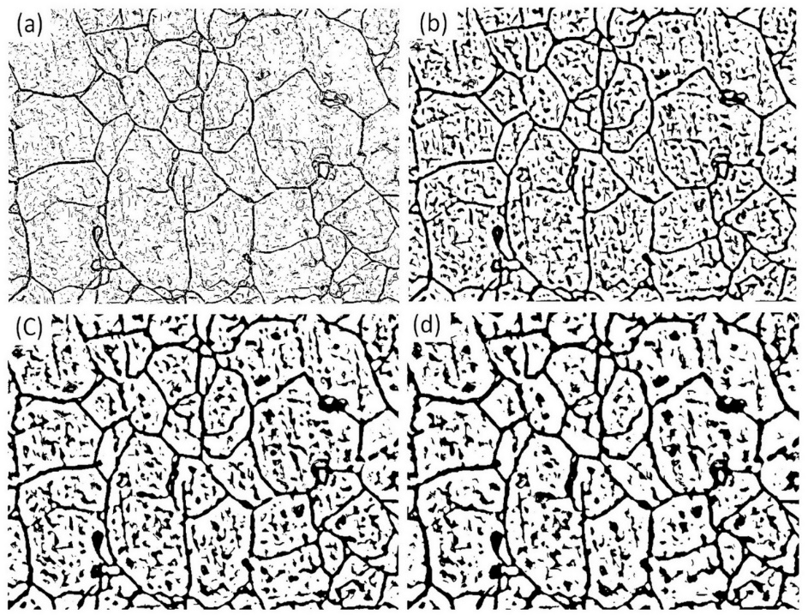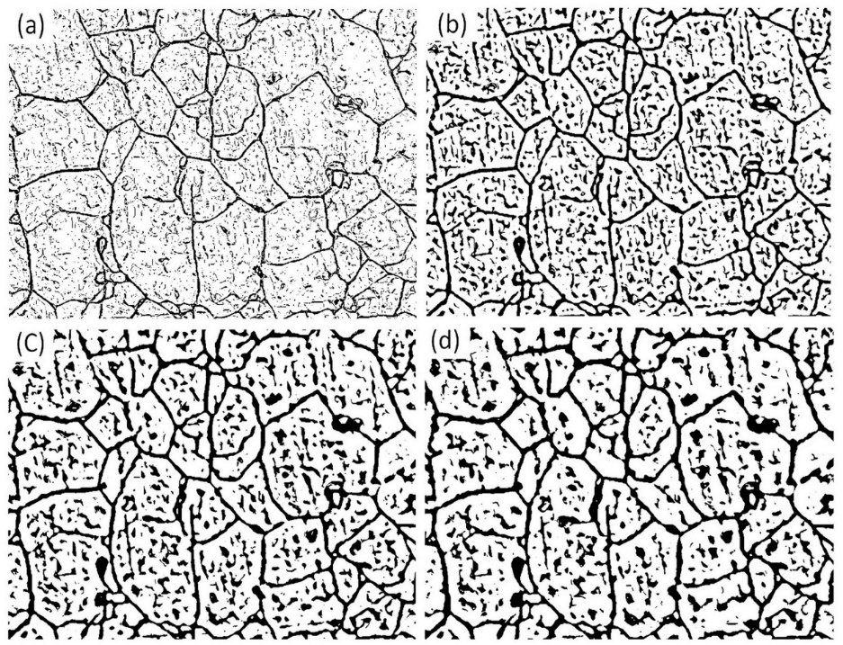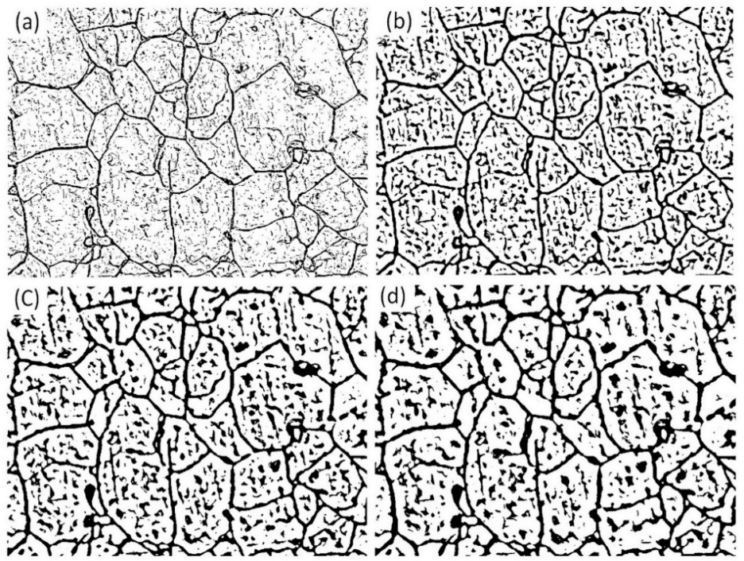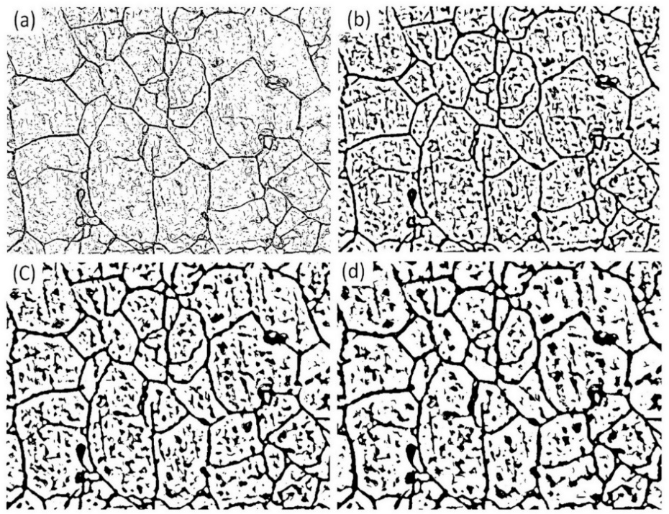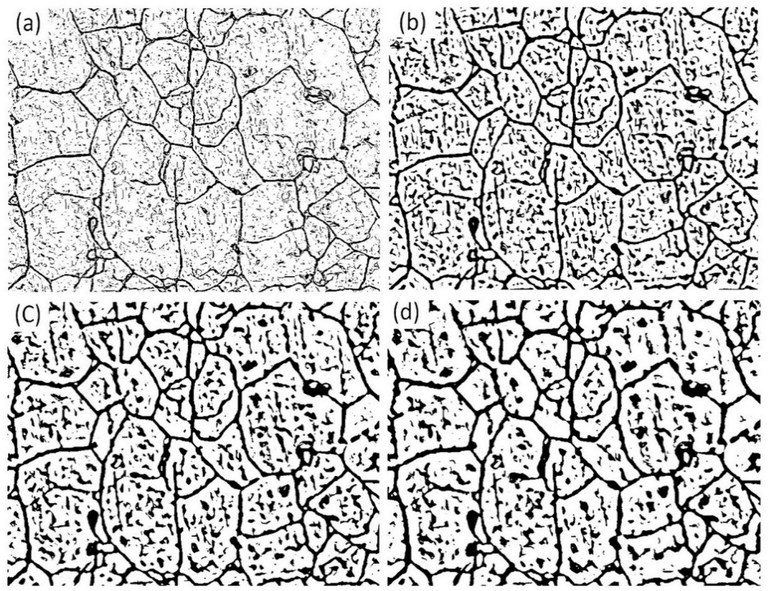

a

b

c

d

10 μm

Fig.4 Edge detection by different scales of the fuzzy model: (a) *n*=5, (b) *n*=15, (c) *n*=25, and (d) *n*=35

value chosen from the two values as the membership degree to reduce the noises. Fig.3c shows that, when a multi-scale model is used, most of the noises can be eliminated.

After the images are processed through the pre-processing using the fuzzy logic edge detection algorithm, the grain boundaries in the images can be extracted.

2.2.3 Edge linking

To meet the requirements of measurement for the grain size, we have to get an enclosing grain boundary. Therefore, the processes to connect the discontinuous grain boundaries are required. The small isolated holes in the images (Fig.3c) must be removed. A Ta value is selected as the area threshold to calculate the area of every isolated hole. If the area of an isolated hole is smaller than Ta, the hole is eliminated. Or else will it be reserved. After this step is completed, most of the isolated holes are eliminated. Then, the methods of mathema tical morphology [14] are chosen to divide the grains. The basic- methods of mathematical morphology include dilation, erosion, open, close, thinning, and so on. Finally, the pruning process is invoked to eliminate the remained burrs [15]. The final result of the grain-edge image is shown as Fig.3d.

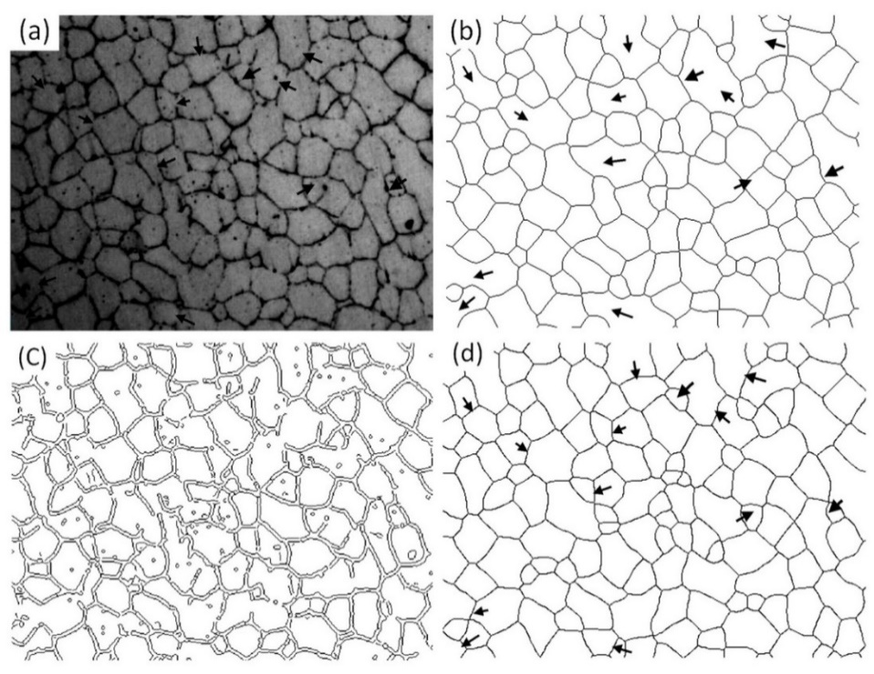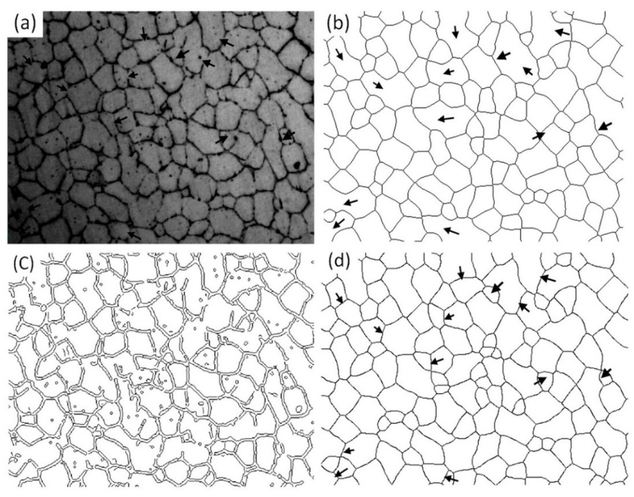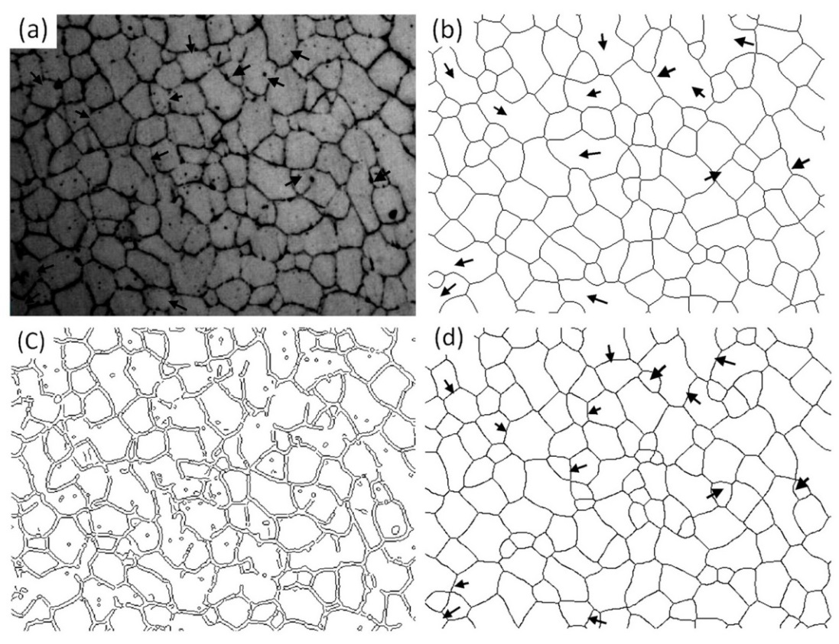

a

b

c

d

10 μm

Fig.5 Results of high quality image: (a) original image, (b) fuzzy logic, (c) Canny, and (d) Image Pro-plus

Through the above processes mentioned, the continuous single-pixel grain boundary images can be obtained as shown in Fig.3d. In the practice, the proposed methodology was tested by processing the images of the 7050 Aluminum alloy specimens and approved with different quality images processed to be superior.

An excellent example is given in Fig.5. The high quality input image in Fig.5 is processed and the results displayed are according to the application Image Pro-plus (Fig.5b), Canny (Fig.5c), and the proposed method (Fig.5d). Fig.5c demonstrates that the Canny operator realizes high recognition rate. As can be seen by comparing Fig.5b and Fig.5d, the proposed method can overcome the drawbacks of IPP applications. The complete, smooth, close and continuous grain boundaries that meet the expectation are obtained. As shown in the figure, numerous discontinuous and fuzzy grain boundaries (arrows) are lost, but they are recognized in the Fig.5b.

Fig.6 gives another example of processing low quality image. The image contains various noises and has low contrast. The edge information is hardly recognized. The commercial software Image Pro-plus even cannot process the image: A manual process has to be utilized to process the image, and is time consuming. The traditional method, such as the Canny operator (Fig.6b), cannot produce satisfied results. The result in Fig.6c indicates that the proposed method overcomes these limitations. The result produced by the proposed method is definitely superior to other traditional methods.

The experiments demonstrate that the proposed method has a good generality of processing digital images. The method effectively deals with a broad range of quality of images. The time consumption of the method is low, which approximately takes about 20 s to completely process a gray-scale metallographic image.

**2.3 Grain size results**

A grain is an area inside the confine of a boundary in a two-dimensional image. Three common methods of calculating the grain sizes are provided in the American Society for Testing Material (ASTM) standard E112-12 [16]. Those are the comparison procedure, the planimetric procedure and the intercept procedure. The comparison procedure does not require counting of the grains, the intercepts, or the intersections. But it compares the images with a series of standard graded images. The planimetric method involves an actual count of number of the grains within a known area. The intercept method involves an actual count of number of the grains intercepted by a test line or number of the grain boundary intersections with a test line, per unit length of the test line. The ASTM standard (E112-12) recommends the planimetric and intercepts methods for higher degrees of accuracy of processing. They have an accuracy of ±0.25 units of the grain size and a repeatability and reproducibility of 0.5 units of the grain size. The intercept method is faster than the planimetric method for the same level of precision.

The intercept method and the planimetric method can produce the same level of accuracy; but the intercept method is faster than the planimetric method. The intercept method is chosen to determine the grain size based on its advantage. The grain size can be calculated as following:

*G*= –6.643 856 log10*l* – 3.288 (5)

where, *l* is the mean intercept length and its unit is mm, and *G* is the grain size in the equation.

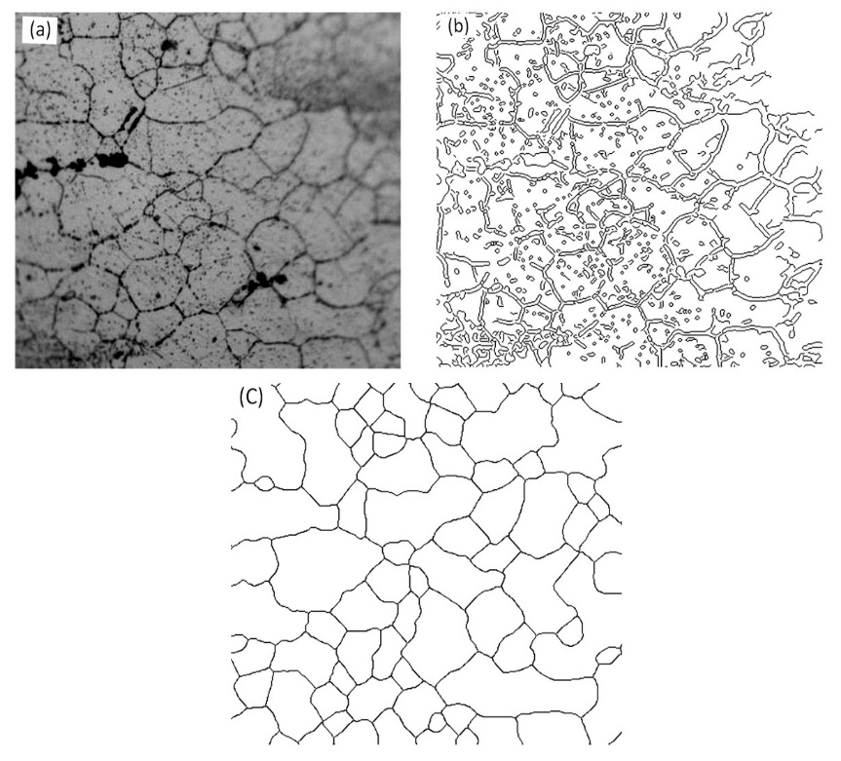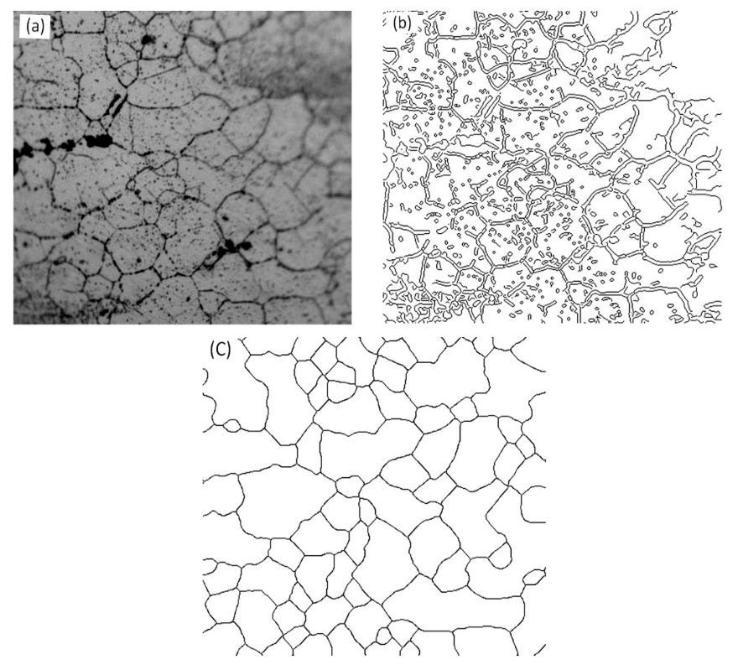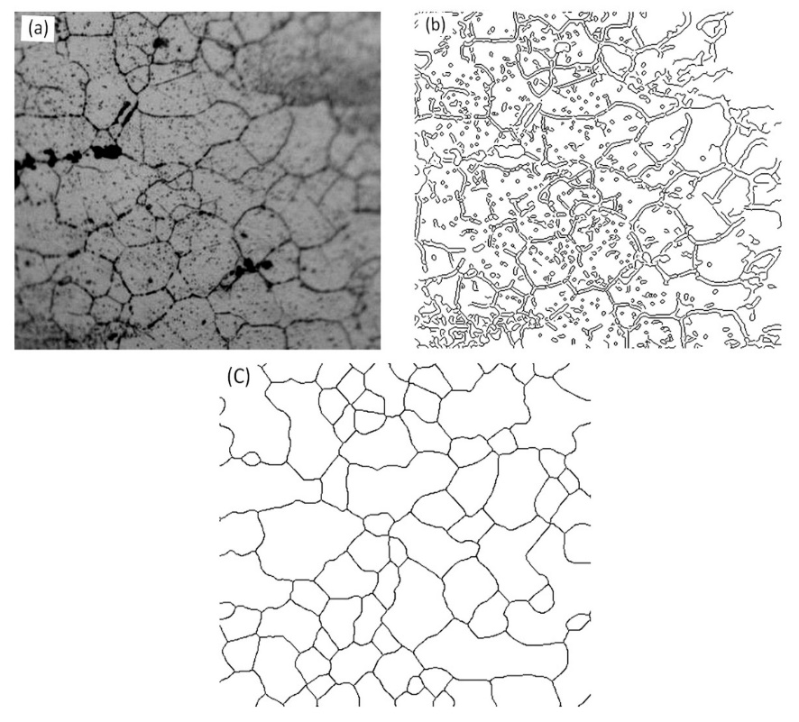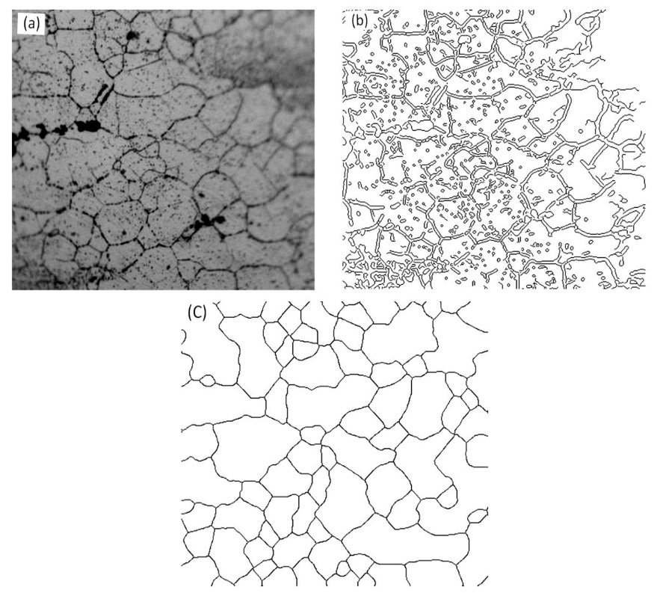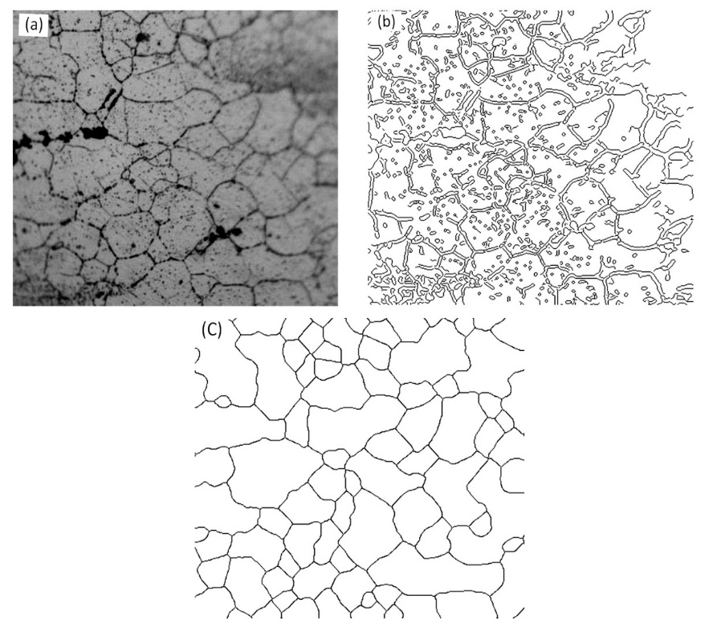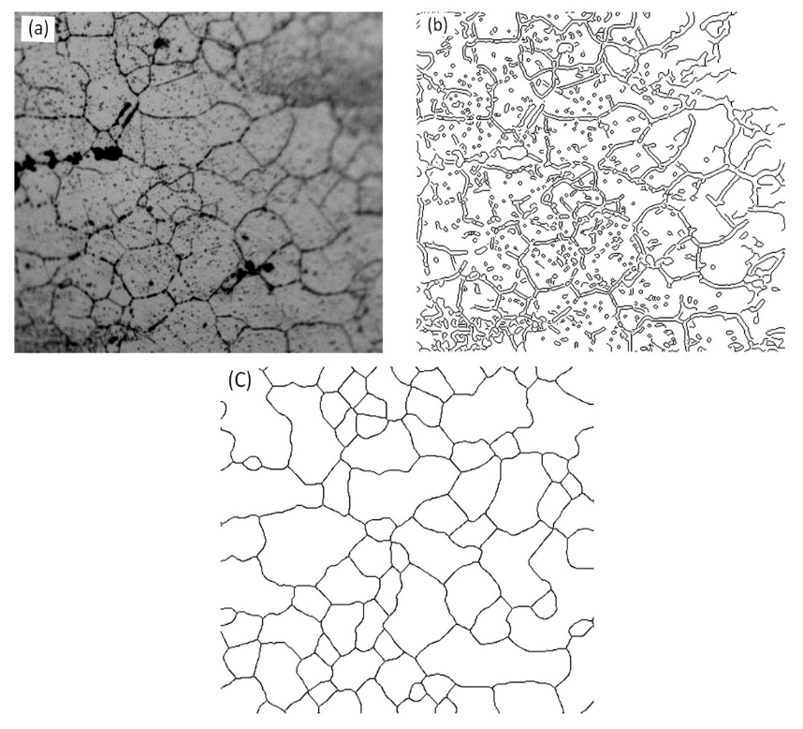

a

b

c

5 μm

Fig.6 Results of low quality images: (a) original image, (b) Canny, and (c) fuzzy logic

**Table 1 Mean intercept length (μm)**

|  |  |  |  |  |  |  |  |  |  |  |  |
| --- | --- | --- | --- | --- | --- | --- | --- | --- | --- | --- | --- |
| No. | 1 | 2 | 3 | 4 | 5 | 6 | 7 | 8 | 9 | 10 | Mean |
| Auto | 7.36 | 7.53 | 7.50 | 7.55 | 7.58 | 7.83 | 7.12 | 8.55 | 6.92 | 7.42 | 7.536 |
| Manual | 8.05 | 7.87 | 7.53 | 7.91 | 7.96 | 8.35 | 7.74 | 8.83 | 7.48 | 7.96 | 7.968 |

Based on the ASTM standard E1382-97(2010)[17], a number of parallel, straight lines with different orientations are chosen as the test grid. Only the lengths of the test lines which intersect grains are measured. The mean intercept length *l* and the grain size G can be calculated from given information. In the experiment, a set of 10 fields with a magnification of 1000× is chosen from the surface of a sample and the measurement is taken.

In order to describe the accuracy of the automatic measurements, 95% confidence interval (95%CI) and the percent of relative accuracy (%RA) are given by Eq.(6) and Eq.(7)

 $95\%CI=±\frac{t·s}{\sqrt{n}}$ (6)

 $\%RA=\frac{95\%CI}{\overline{l}}$ (7)

where, *n* is the number of fields measured, *t* is constant multiplier specified by the standard, *l* is the mean value of the intercept length, and *s* is standard deviation. As a general rule, a 10% RA (or lower) is considered to be an acceptable precision for most purposes.

Table 1 displays the mean intercept lengths of the 10 images of the 10 fields measured by the automatic method and the manual method. The results obtained by processing the data in the table utilizing an automatic method are usually higher than that measured by a manual method. The mean value is about 5.7% higher than that of the automatic method because the discontinuous grain boundaries can be restored and the intersections between the grain boundaries and the test lines will be increased after the image is processed. The average value of *G* calculated via the formula (1) is 10.79. Table 2 shows the results of 95%CI and %RA. When *n* is greater than 5, the values of the %RA are all less than 10. Therefore, the measurement results are acceptable.

**Table 2 Results of 95%CI and %RA**

|  |  |  |
| --- | --- | --- |
| Fields, *n* | 95%CI | %RA |
| 5 | ±0.106 287 019 | 1.416 404 84 |
| 6 | ±0.161 163 182 | 2.132 258 201 |
| 7 | ±0.200 708 357 | 2.677 641507 |
| 8 | ±0.354 069 984 | 4.642 018 804 |
| 9 | ±0.354 347 089 | 4.694 029 733 |
| 10 | ±0.312 252 126 | 4.143 473 015 |

**3 Summary**

The grain size automatic determination by utilizing the digital image processing technology is an important tool in the material microstructure analysis. In the research, the fuzzy logic edge detection algorithm is proposed to extract and reconstruct the grain boundary by combining mathematical morphology based on the defects and the features existing in metallographic images of the 7050 aluminum alloy. The comparison of experimental results illustrates that the proposed method is absolutely superior to the traditional methods of processing high strength aluminum alloy metallographic images. The grain boundaries obtained through the proposed method are more complete and continuous in a shorter time. In order to enhance the method with accuracy and performance, the research will be continued, and an enhanced image processing algorithms of performing metallography analysis will applied. After the digital image is processed by the proposed method, more thorough parameters, such as shape factor, and fractal dimensions, can be used to describe microstructure characteristics, and build a characterization system for the high strength aluminum alloy.

References

1. Shan L N, Li D Y. *China Foundry Machinery & Technology*[J], 2005(1): 4 (in Chinese)
2. Tan W, Wu C, Zhao S. *Mining and Metallurgy*[J], 2009(1): 22 (in Chinese)
3. Ortalan V, Herrera M, Morgan D G *et al.* *Ultramicroscopy*[J], 2009, 110: 67
4. Peregrina-Barreto H, Terol-Villalobos I R, Rangel-Magdaleno J J *et al*. *Measurement*[J], 2013, 46(1): 249
5. Wang K X, Zeng W D, Zhao Y Q *et al*. *Rare Metal Materials and Engineering*[J], 2011, 40(5): 784 (in Chinese)
6. Sowmya Mahadevan, David Casasent. *Ultramicroscopy*[J], 2010, 96: 153
7. Jiang M X, Chen G H. *Optics and Precision Engineering*[J], 2011, 10: 33 (in Chinese)
8. Deng S C, Liu T G, Xiao Z X. *Optics and Precision Engineering*[J], 2010, 18(10): 2314 (in Chinese)
9. Park C, Huang J Z, Ding Y *et al*. *IIE Transactions*[J], 2012, 44(7): 507
10. Orhan Dengiz, Alice E Smith, Ian Nettleship. *Computers in Industry*[J], 2005, 56: 854
11. Łukasz R, Łukasz S, Kusiak J*.* *Artifical Intelligence and Soft Computing* [M].Heidelberg: Springer Berlin, 2010: 80
12. Vertan Constantin, Stoica Adrian, Fernandez-Maloigne Christine. *The 10th IEEE International Conference* Vol. 1[C]. Melbourne: IEEE, 2001
13. He X, Teng Q, Zhang Y. *Physical Testing and Chemical Analysis, Part A Physical Testing*[J], 2005, 11: 6 (in Chinese)
14. Cui Q. *Image Processing and Analysis-Methods and Applications of Mathematical Morphology*[M]. Beijing: Science Press, 2000 (in Chinese)
15. Hu Y J, Yan C H, Hu H X*. Journal of Nanchang Hangkong University*, *Natural Science*[J], 2009(1): 38 (in Chinese)
16. ASTM Standard E112-12[S], 2012
17. ASTM Standard E1382-97[S], 2010

基于模糊逻辑的**7050**铝合金晶粒度自动分析方法的研究

张利欣1,2，徐正光1，魏帅岭1,3，任学冲2，王美玲2

(1. 北京科技大学自动化学院，北京 100083)

(2. 北京科技大学国家材料服役安全科学中心，北京 100083)

(3. 邯郸中心医院信息科，河北 邯郸 056001)

摘 要：晶粒度是高强度铝合金微观组织分析的关键参数。通常是由人工手动获得，整个过程耗时且容易出错。目前随着数字图像处理技术和模式识别技术的快速发展，为定量金相分析提供了一种新的方法。利用人工智能实现自动金相分析可以克服手工工艺的缺点。在本文中提出了确定的金相图像的晶粒尺寸的数字图像处理的一种新方法。基于模糊逻辑的边缘检测算法的提取晶界。并对不同方法的金相图像提取方法进行了对比，验证了该方法的有效性。并基于美国材料试验学会（ASTM）标准获得了晶粒度等微观组织参数。

关键词：微观结构分析；晶粒度；模糊逻辑；边缘提取；铝合金

作者简介：张利欣，女，1977年生，博士生，高级工程师，北京科技大学自动化学院，北京 100083，电话：010-62332239，E-mail: lxzhang@ustb.edu.cn